**Food Box Project Outputs**

**-SIRIKI KISHORE**

**HOMEPAGE**

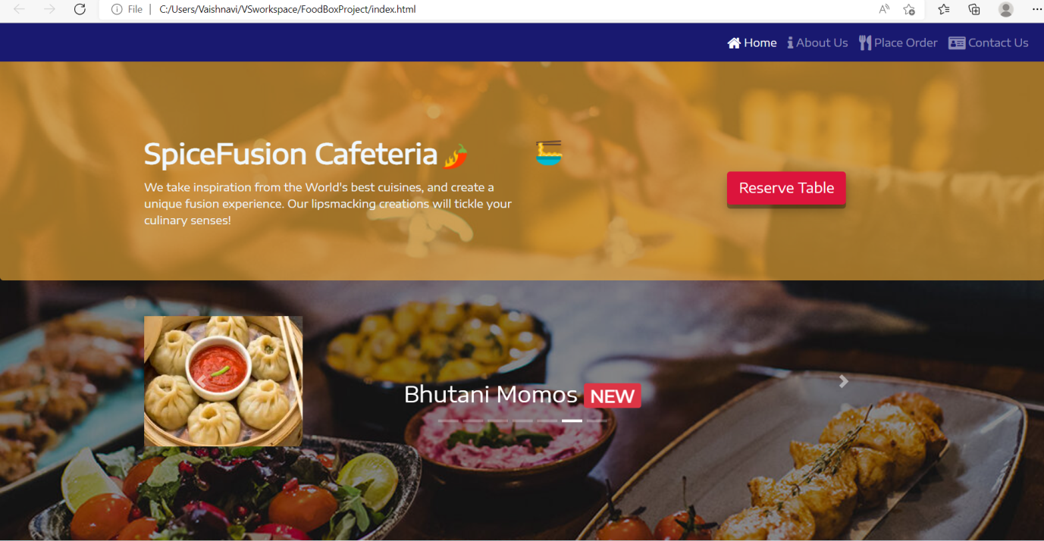

**ABOUT US**

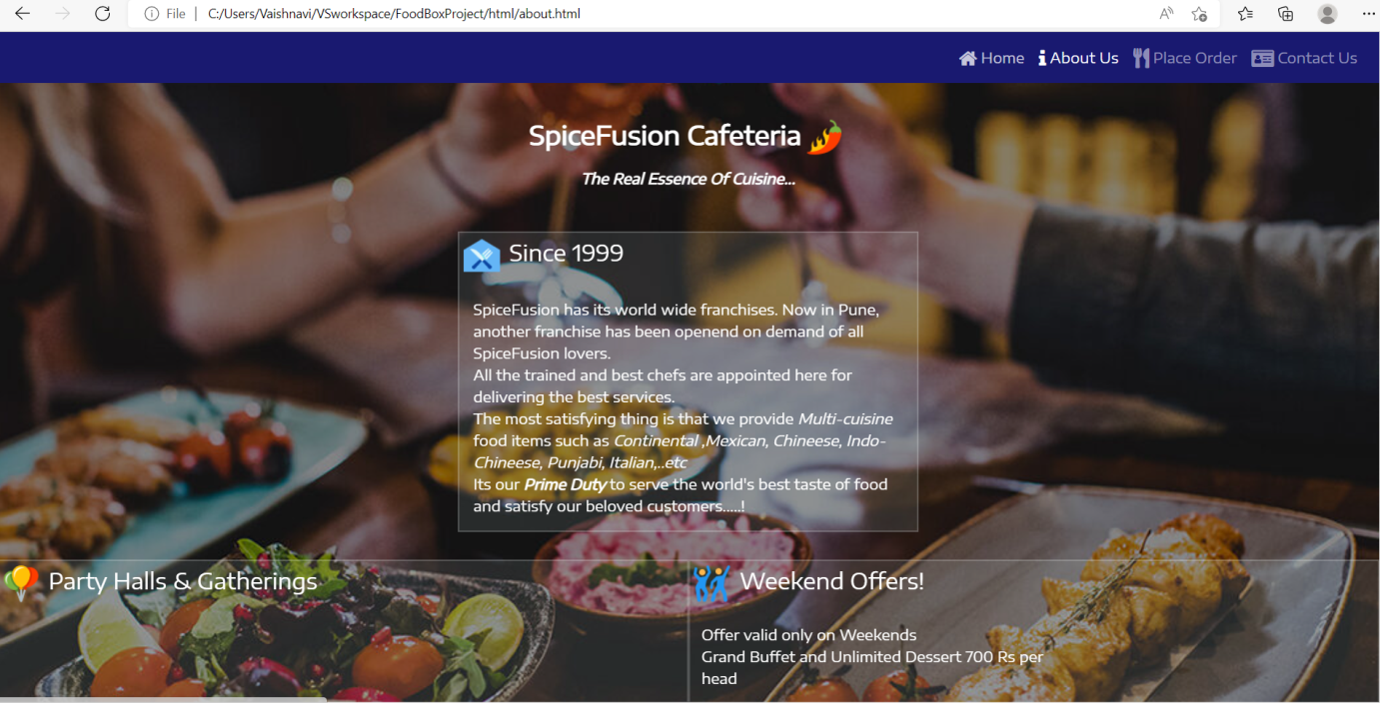

**PLACE ORDER**

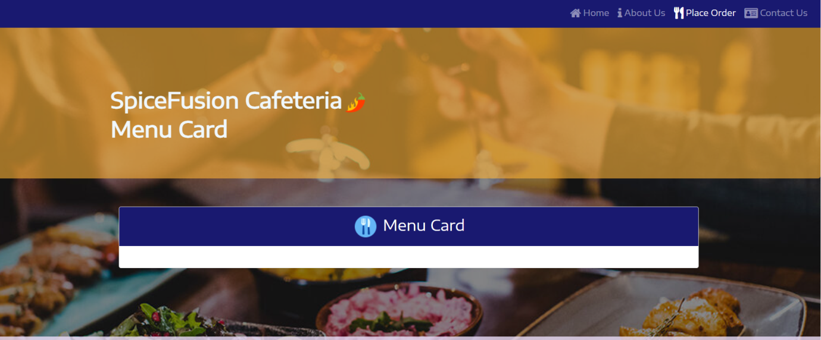

**CONTACT US**

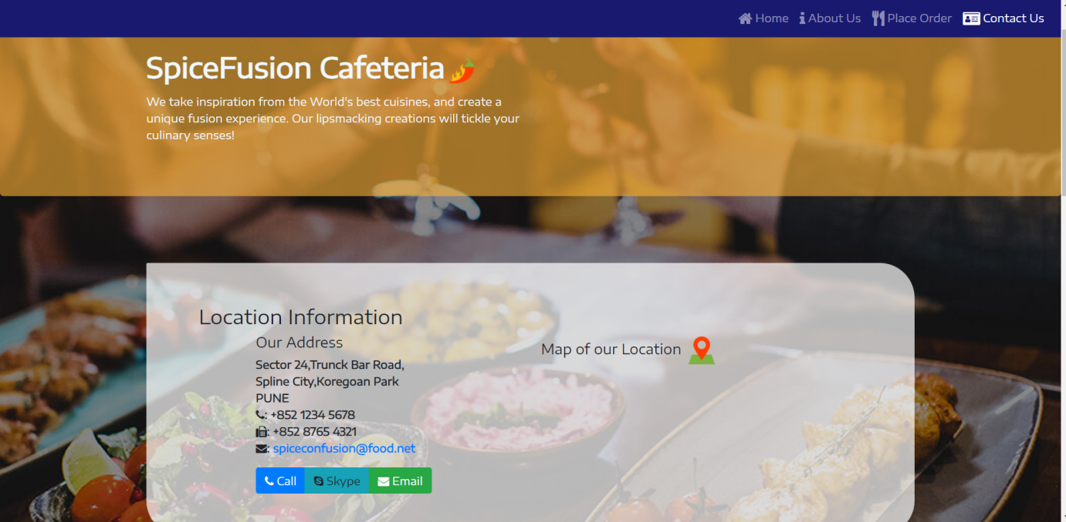

**RESERVE TABLE**

